**Department of Information Technology**

**Academic Year: 2018-19** **Semester: V**

**Class / Branch: TE IT**

**Subject: OLAP Lab**

**Instructional steps to install SQL Server instance**

1. Go to :

**C:\SQLServer2017Media\Developer_ENU**

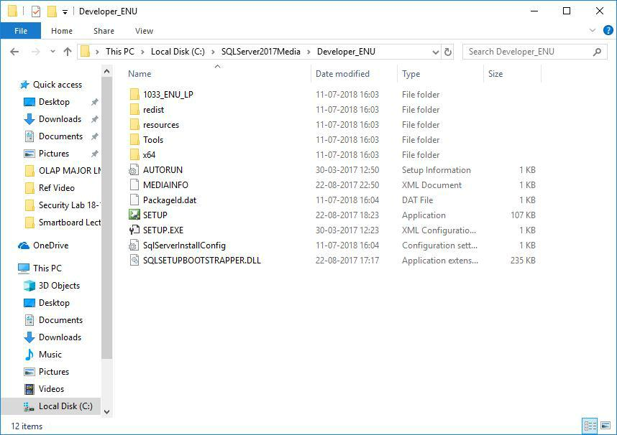

1. **Run SETUP file**
2. **Yes**
3. **From below window select installation and the first option New SQL server stand-alone installation**

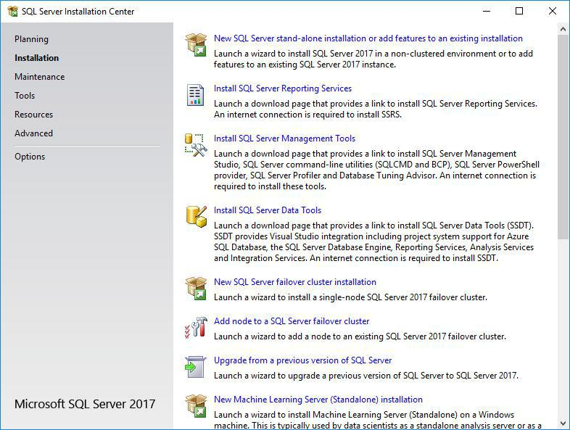

1. **Microsoft update : click Next**
2. **Product Update : click Next**
3. **Install set up runs automatically**
4. **Install Rules : you will get window below, click Next**

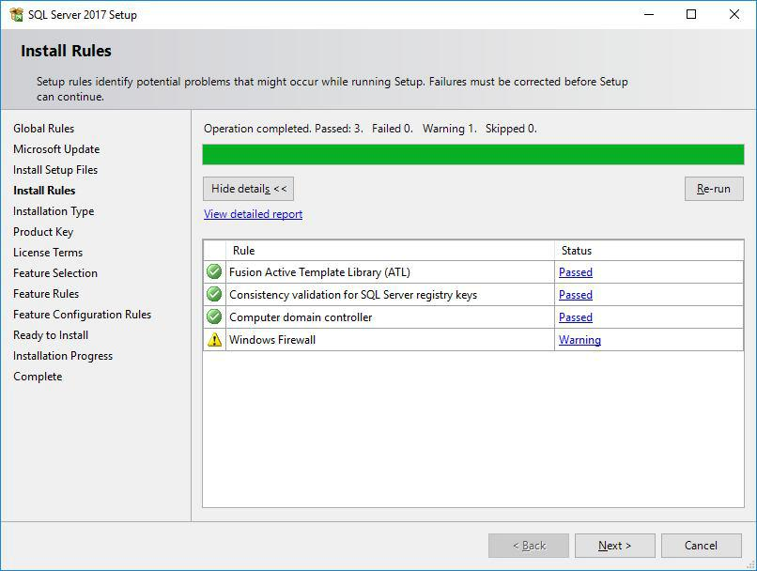

1. **Installation Type: select Perform new installation of SQL Server 2017 and click Next. This window lists the instances already installed on your system.**

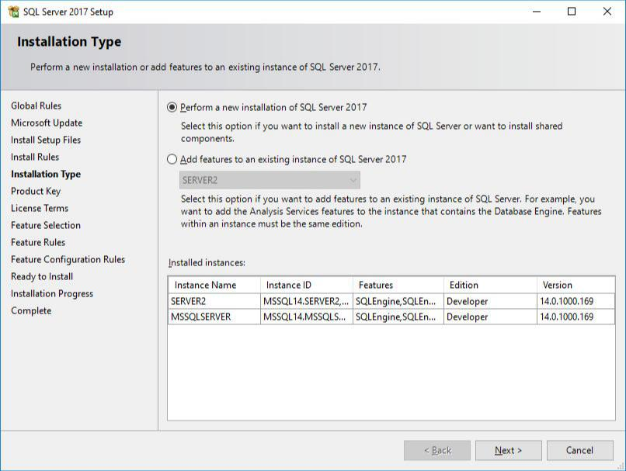

1. **Product Key: Select specify free edition. Select Developer and click Next.**
2. **License Terms : Select I accept the license terms and click Next**

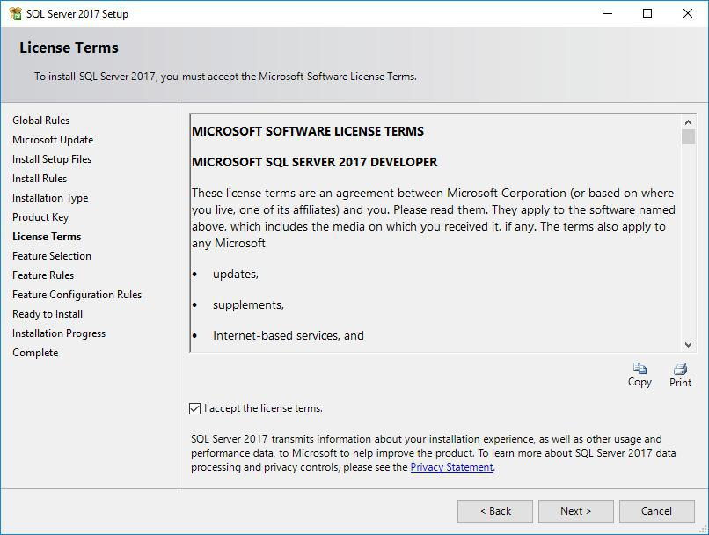

1. **Feature Selection: Click Select All. Uncheck i) Machine Learning Services from both instance features and sharing features. Ii) Polybase Query service for external data. Features can be modified as per the requirements. And then click Next**

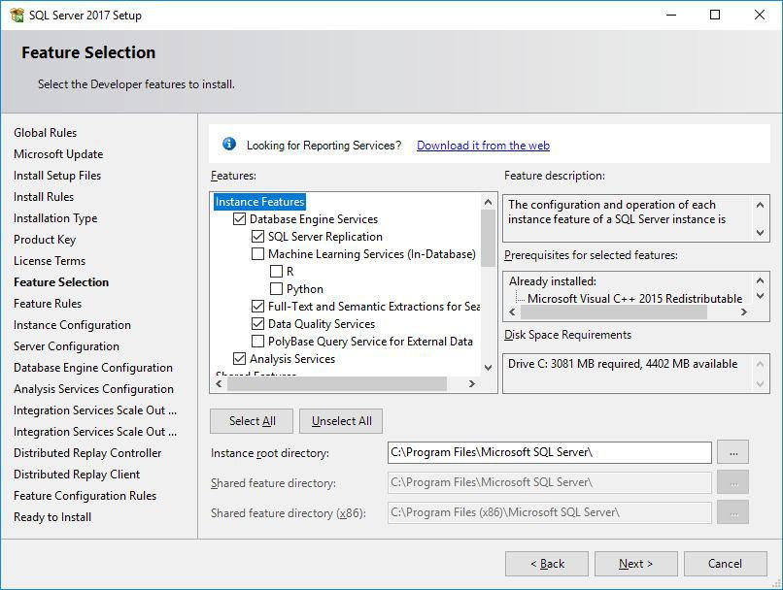

**13. Instance Configuration : Important step. Select named instance and specify a name**

**for your server instance and click Next**

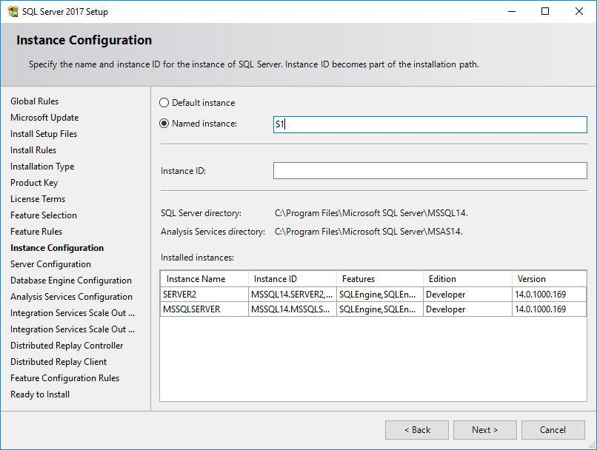

1. **Server Configuration:**

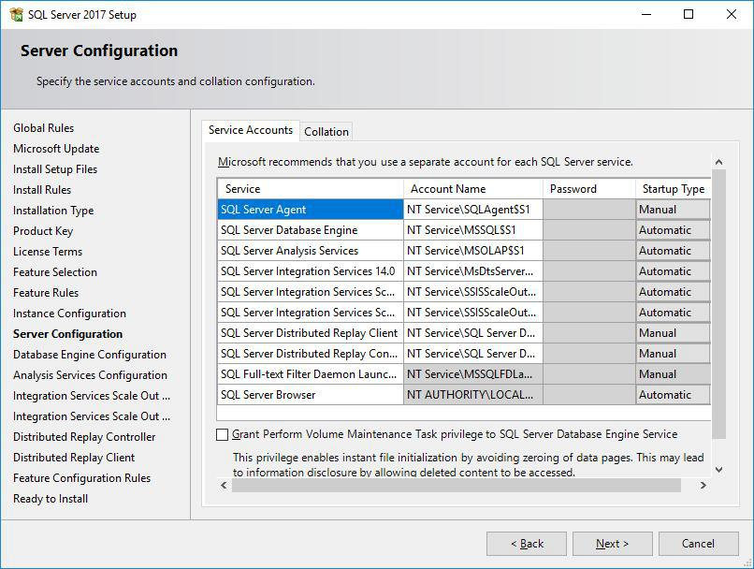

**15. Database Engine Configuration:**

**Select Mix-mode authentication. Key in password for sa(Server administrator). Add current user and click Next**

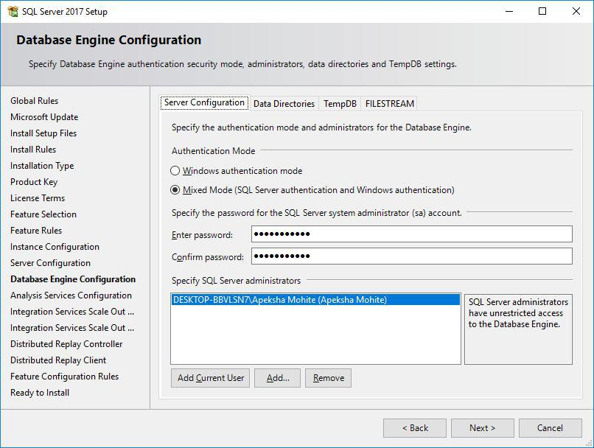

**16. In file stream tab: enable the accesses.**

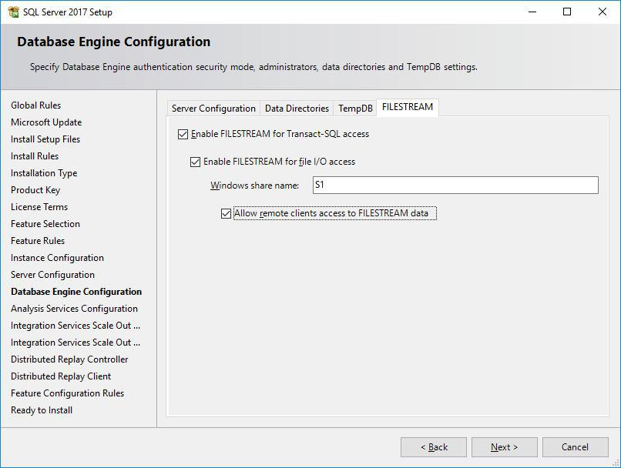

1. **Analysis Server Configuration: Add current user and click Next.**

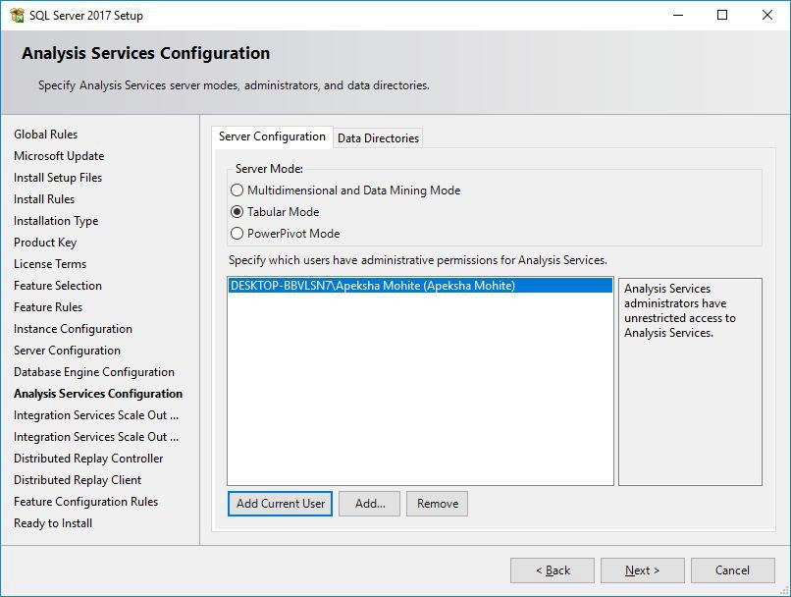

1. **Integration Services Master Node: Click Next**
2. **Integration Services Worker Node: Click Next**
3. **Distributed Replay Controller: Click Next**
4. **Distributed Replay Client: Click Next**
5. **Ready to install: Click Install**

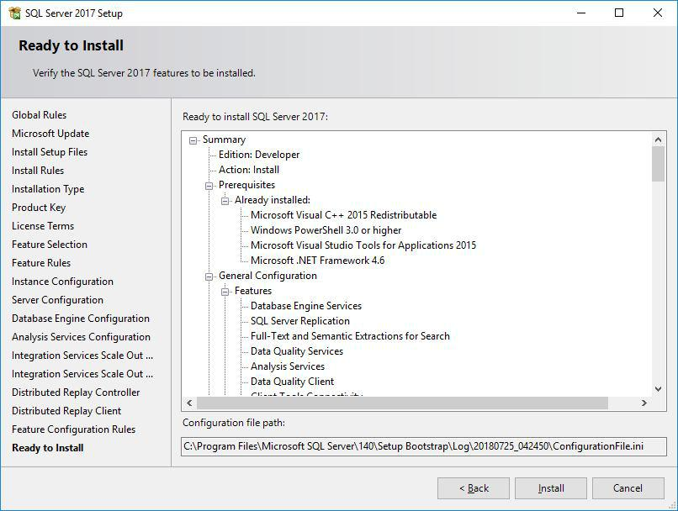

**23. Install Progress:**

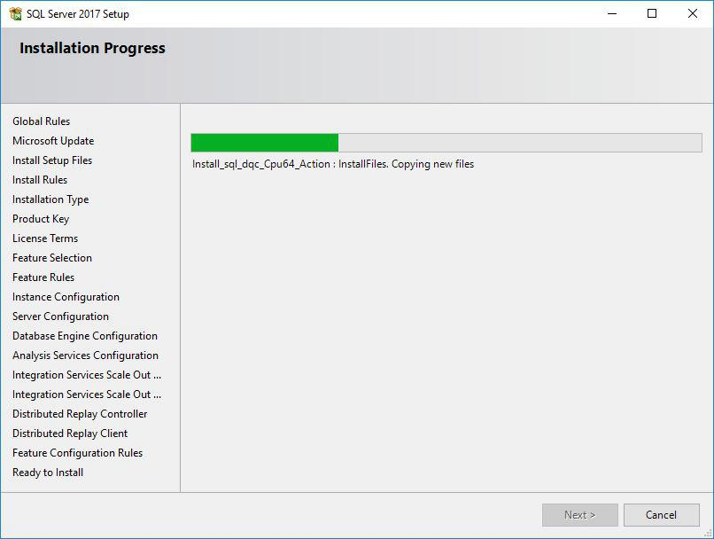

**24. Installation Complete:**

